**Assignment – 5**

**-Sai Sree Mithra Sripathi**

**Load “iris.csv” dataset and store it into a local R variable named “iris” using “read.csv” R command.**

**Display the content of the “iris” variable by typing the variable name in RStudio. The first line of the dataset has the feature names in the form of something like:**

|  |  |  |  |  |  |  |
| --- | --- | --- | --- | --- | --- | --- |
|  |  | **X5.1** | **X3.5** | **X1.4** | **X0.2** | **Iris-setosa** |
| **1** | **4.9** | **3.0** | **1.4** | **0.2** | **Iris-setosa** |  |
| **2** | **...** | **...** | **...** | **...** | **...** |  |

*iris<-read.csv("iris.csv")*

*iris*

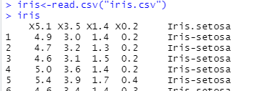

*str(iris)*

*names(iris)*

*names(iris)[names(iris)=="X5.1"]<-"sepal_length"*

*names(iris)<-gsub("X3.5","sepal_width", names(iris))*

*names(iris)<-gsub("X1.4","petal_length", names(iris))*

*names(iris)<-gsub("X0.2","petal_width",names(iris))*

*names(iris)<-gsub("Iris.setosa","class",names(iris))*

*names(iris)*

*summary(iris)*

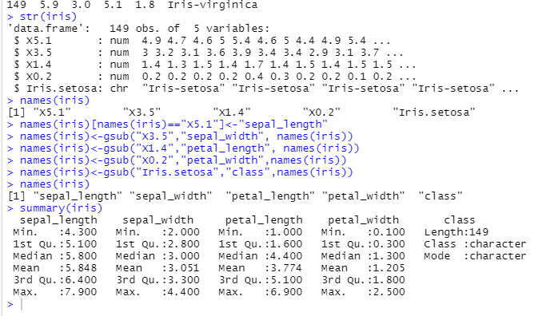

**According to the dataset description on the UCI Machine Learning Repository, these features correspond to sepal_length, sepal_width, petal_length, petal_width, and class. To clean this up, use the R command colnames to rename the column names according to the dataset description in the UCI Machine Learning Repository.**

**After doing so, if you display the content of the “iris” variable you should see something like:**

|  |  |  |  |  |  |
| --- | --- | --- | --- | --- | --- |
|  | **sepal_length** | **sepal_width** | **petal_length** | **petal_width** | **class** |
| **1** | **4.9** | **3.0** | **1.4** | **0.2** | **Iris-setosa** |
| **2** | **...** | **...** | **...** | **...** | **...** |

**Now that your data is ready, select the features you will use for clustering using the k-means algorithm. In one run, use the sepal_length and sepal_width features. You can do so by storing the two features in a local variable called   
  
  
  
kmeans_sepal: kmeans_sepal <- data.frame(iris$sepal_length, iris$sepal_width)**

**In another run, use petal_length and petal_width features and save them in a local variable called kmeans_petal.**

**Start training a clustering model of your data using the k-means algorithm.**

**For the kmeans_sepal variable, run the k-means algorithm for 3 clusters.**

K-MEANS Clustering:

K-means clustering is one of the most commonly used unsupervised machine learning algorithm for partitioning a given data set into a set of k groups (i.e. k clusters), where k represents the number of groups pre-specified by the analyst.

Kmeans command : Perform k-means clustering on a data matrix.

Kmeans() function returns a list of components, including:

* cluster: A vector of integers (from 1:k) indicating the cluster to which each point is allocated
* centers: A matrix of cluster centers (cluster means)
* totss: The total sum of squares (TSS), i.e ∑(xi−x¯)2∑(xi−x¯)2. TSS measures the total variance in the data.
* withinss: Vector of within-cluster sum of squares, one component per cluster
* tot.withinss: Total within-cluster sum of squares, i.e. sum(withinss)sum(withinss)
* betweenss: The between-cluster sum of squares, i.e. totss−tot.withinsstotss−tot.withinss
* size: The number of observations in each cluster

*kmeans_sepal = data.frame(iris$sepal_length, iris$sepal_width)*

*kmeans_petal = data.frame(iris$petal_length,iris$petal_width)*

*sepal = kmeans(kmeans_sepal,3)*

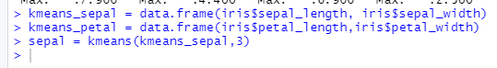

**Plot the outcome of your clustering model using clusplot R command, e.g., clusplot(iris, sepal$cluster, color=TRUE, shade=TRUE, labels=5, lines=0).**

**For the kmeans_petal variables, run the k-means algorithm for 4 clusters and plot the outcome.**

**Note that to use the clusplot R command, you need to load cluster library.**

*library("cluster")*

*clusplot(iris, sepal$cluster, color = TRUE, shade = TRUE, labels = 5, lines = 0)*

*petal = kmeans(kmeans_petal,4)*

*clusplot(iris, petal$cluster, color = TRUE, shade = TRUE, labels = 5, lines = 0)*

When we use 4 in sepal length –

*sepal = kmeans(kmeans_sepal,4)*

*clusplot(iris, sepal$cluster, color = TRUE, shade = TRUE, labels = 5, lines = 0)*

Then the plot looks like:

The count defines the number of clusters to be categorized into. First when a count of 3 was given the data is divided as 3 clusters. When we give a count of 4, the entire data is categorized as 4 clusters.

**References:**

https://www.datanovia.com/en/lessons/k-means-clustering-in-r-algorith-and-practical-examples/